<http://ms-iot.github.io/content/en-US/GetStarted.htm>

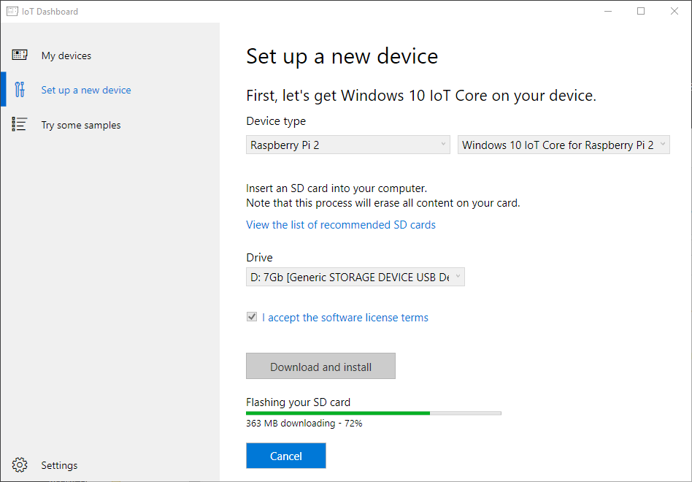

It confirms to overwrite the SD Card halfway through the progress Why can’t it ask at the beginning?!

Even after downloading template I only got just one?!

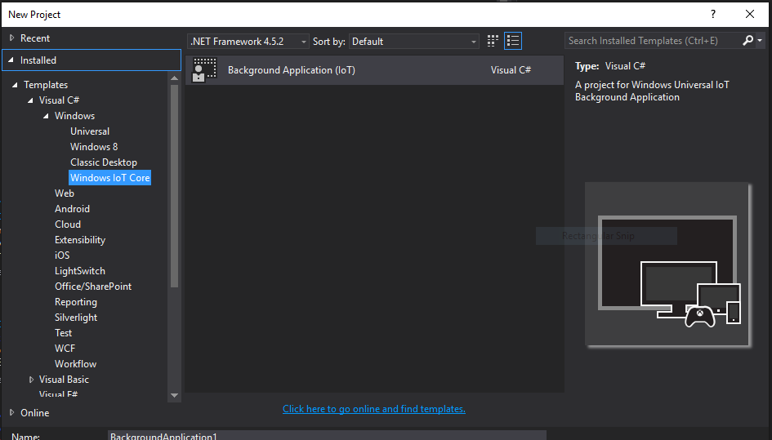

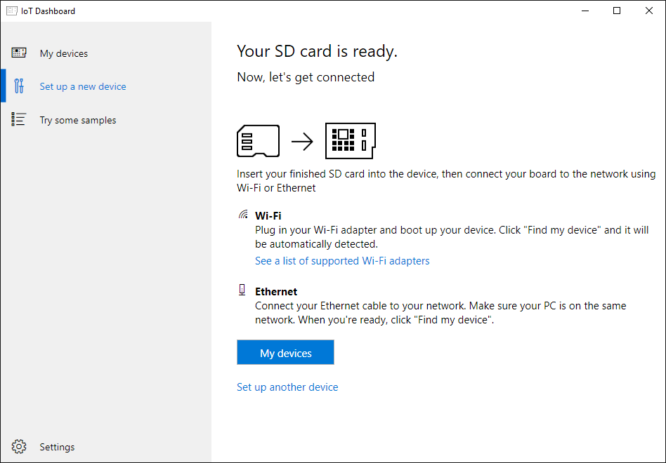

When done, eject the SD card, put it in Pi and boot it up.

It takes forever (about 3 minutes?) before it gets pass the windows logo and the spinning progress.

You have to connect keyboard and mouse to the Pi so you can pick language and password.

It did not recognize my WiFi dongle ☹ Had to connect it to Ethernet jack ☹

But it showed up in the IoT dashboard when I plugged in the Ethernet!

